

Team Members: Evan Hudson, Todd Askren, Mileah Joy, Lee Laffitte, Kobe Herrington

Group Meetings

Meeting: 1

September 1

* Meeting in class
* All members present
* 2:08-3 Came up with the name “Mighty Pythons” because we are computer science majors and “Python” is a coding program.
* The mascot/symbol of our group is a snake to represent Pythons.

Meeting: 2

September 8

* Meeting in class
* All members present
* 2:32- 3
* Came up with non-profit Options:
* MedReach
* The Ability Experience
* Saraland School System (clubs

Meeting 3

September 20

* Meeting in class
* All members present
* 2:23-3
* We decided on MedReach for our non-profit organization.
* Worked on project progress report 1.

Meeting: 4

October 11

* Meeting in class
* 4 members present (Evan, Todd, Mileah, Kobe)
* 2:05-3
* Community Service for MedReach: Packaging glasses, creating an inventory list (October 21-22)
* Need to divide up the work for Inventory List and project report

Meeting: 5

October 22

* 2:30-5:00 Meeting at a storage facility with a representative from Medreach
* 3 members present (Evan, Lee, Mileah)
* Sorting and packaging both sunglasses and prescription glasses that will be sent to Africa.

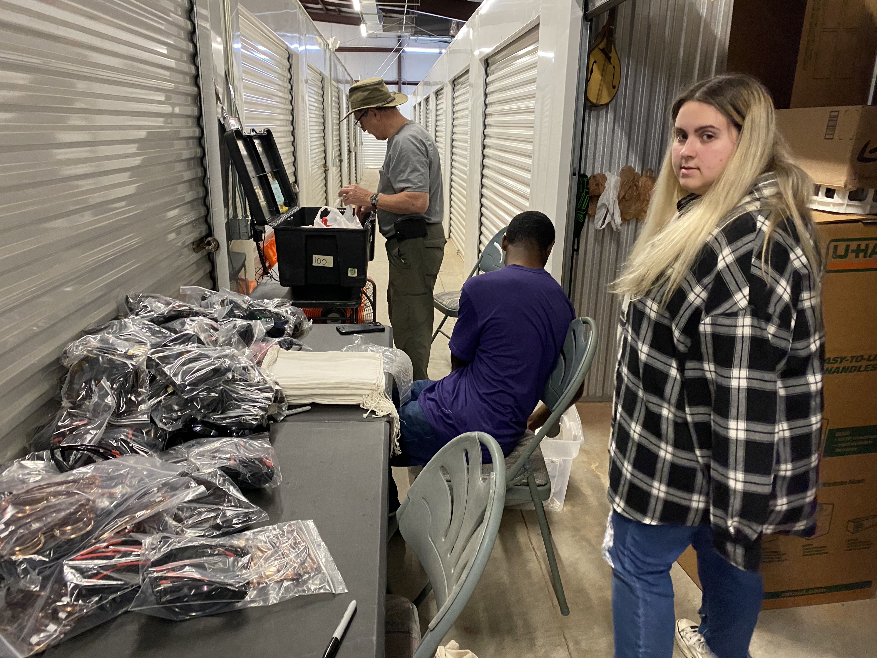 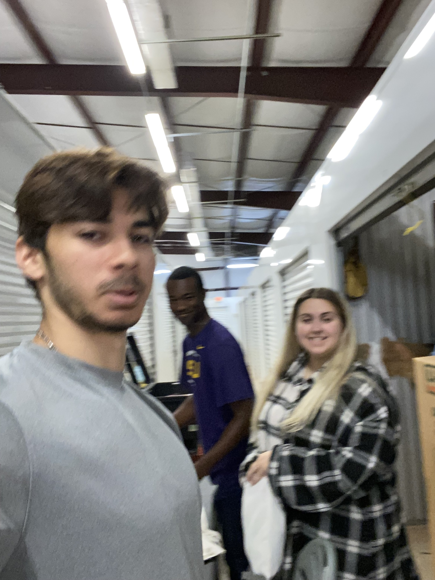

Meeting: 6

October 29

* 2:30-5:00 Meeting at a storage facility with a representative from Medreach
* 2 members present (Evan and Kobe)
* Sorting and building shelves

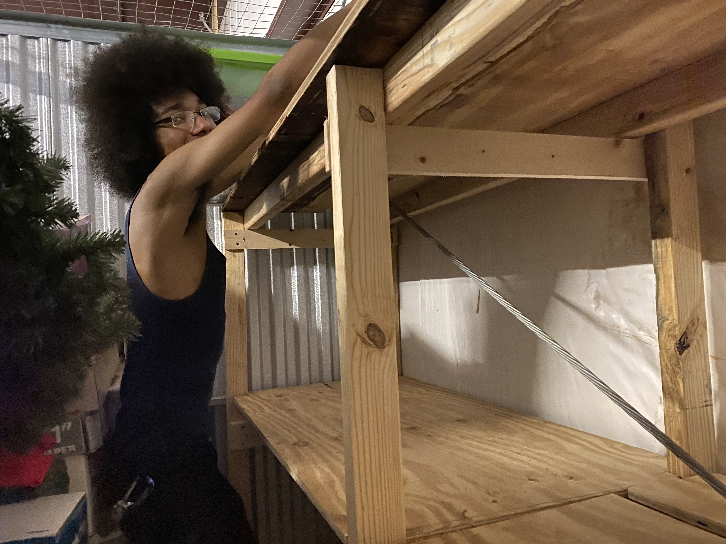

Meeting: 7

November 3

* 2:00-3:00 Meeting at Recreational Center
* Mileah, Evan, Kobe, and Lee(virtually) present
* Working on Inventory list and writing for presentation

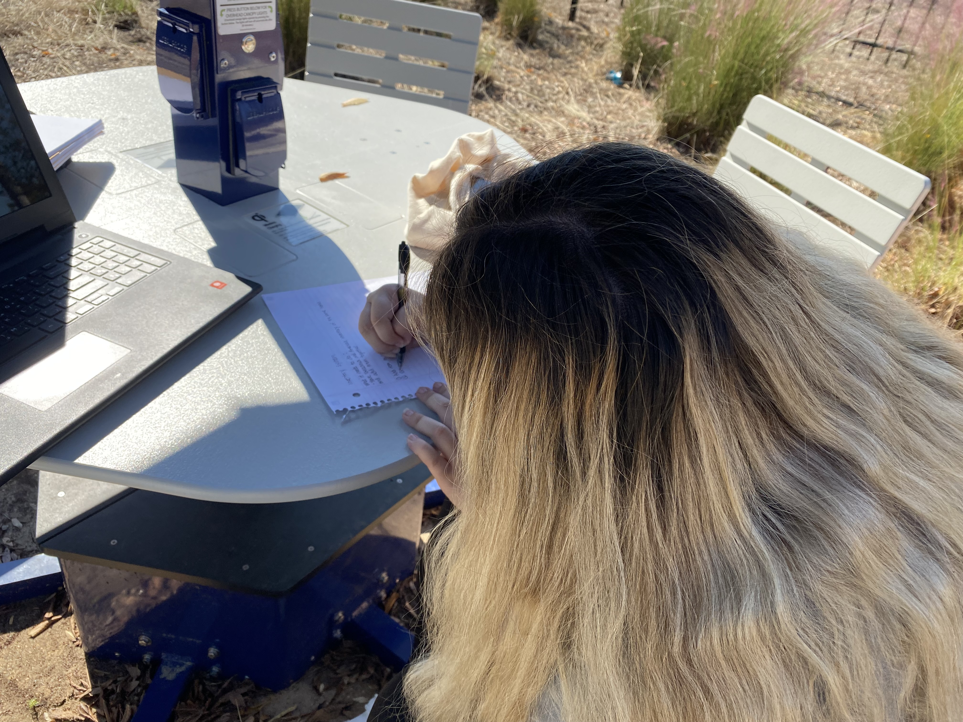

Meeting: 8

November 5

* 2:00-4:00 Meeting at dorm
* Evan and Todd
* Working on code/fixing

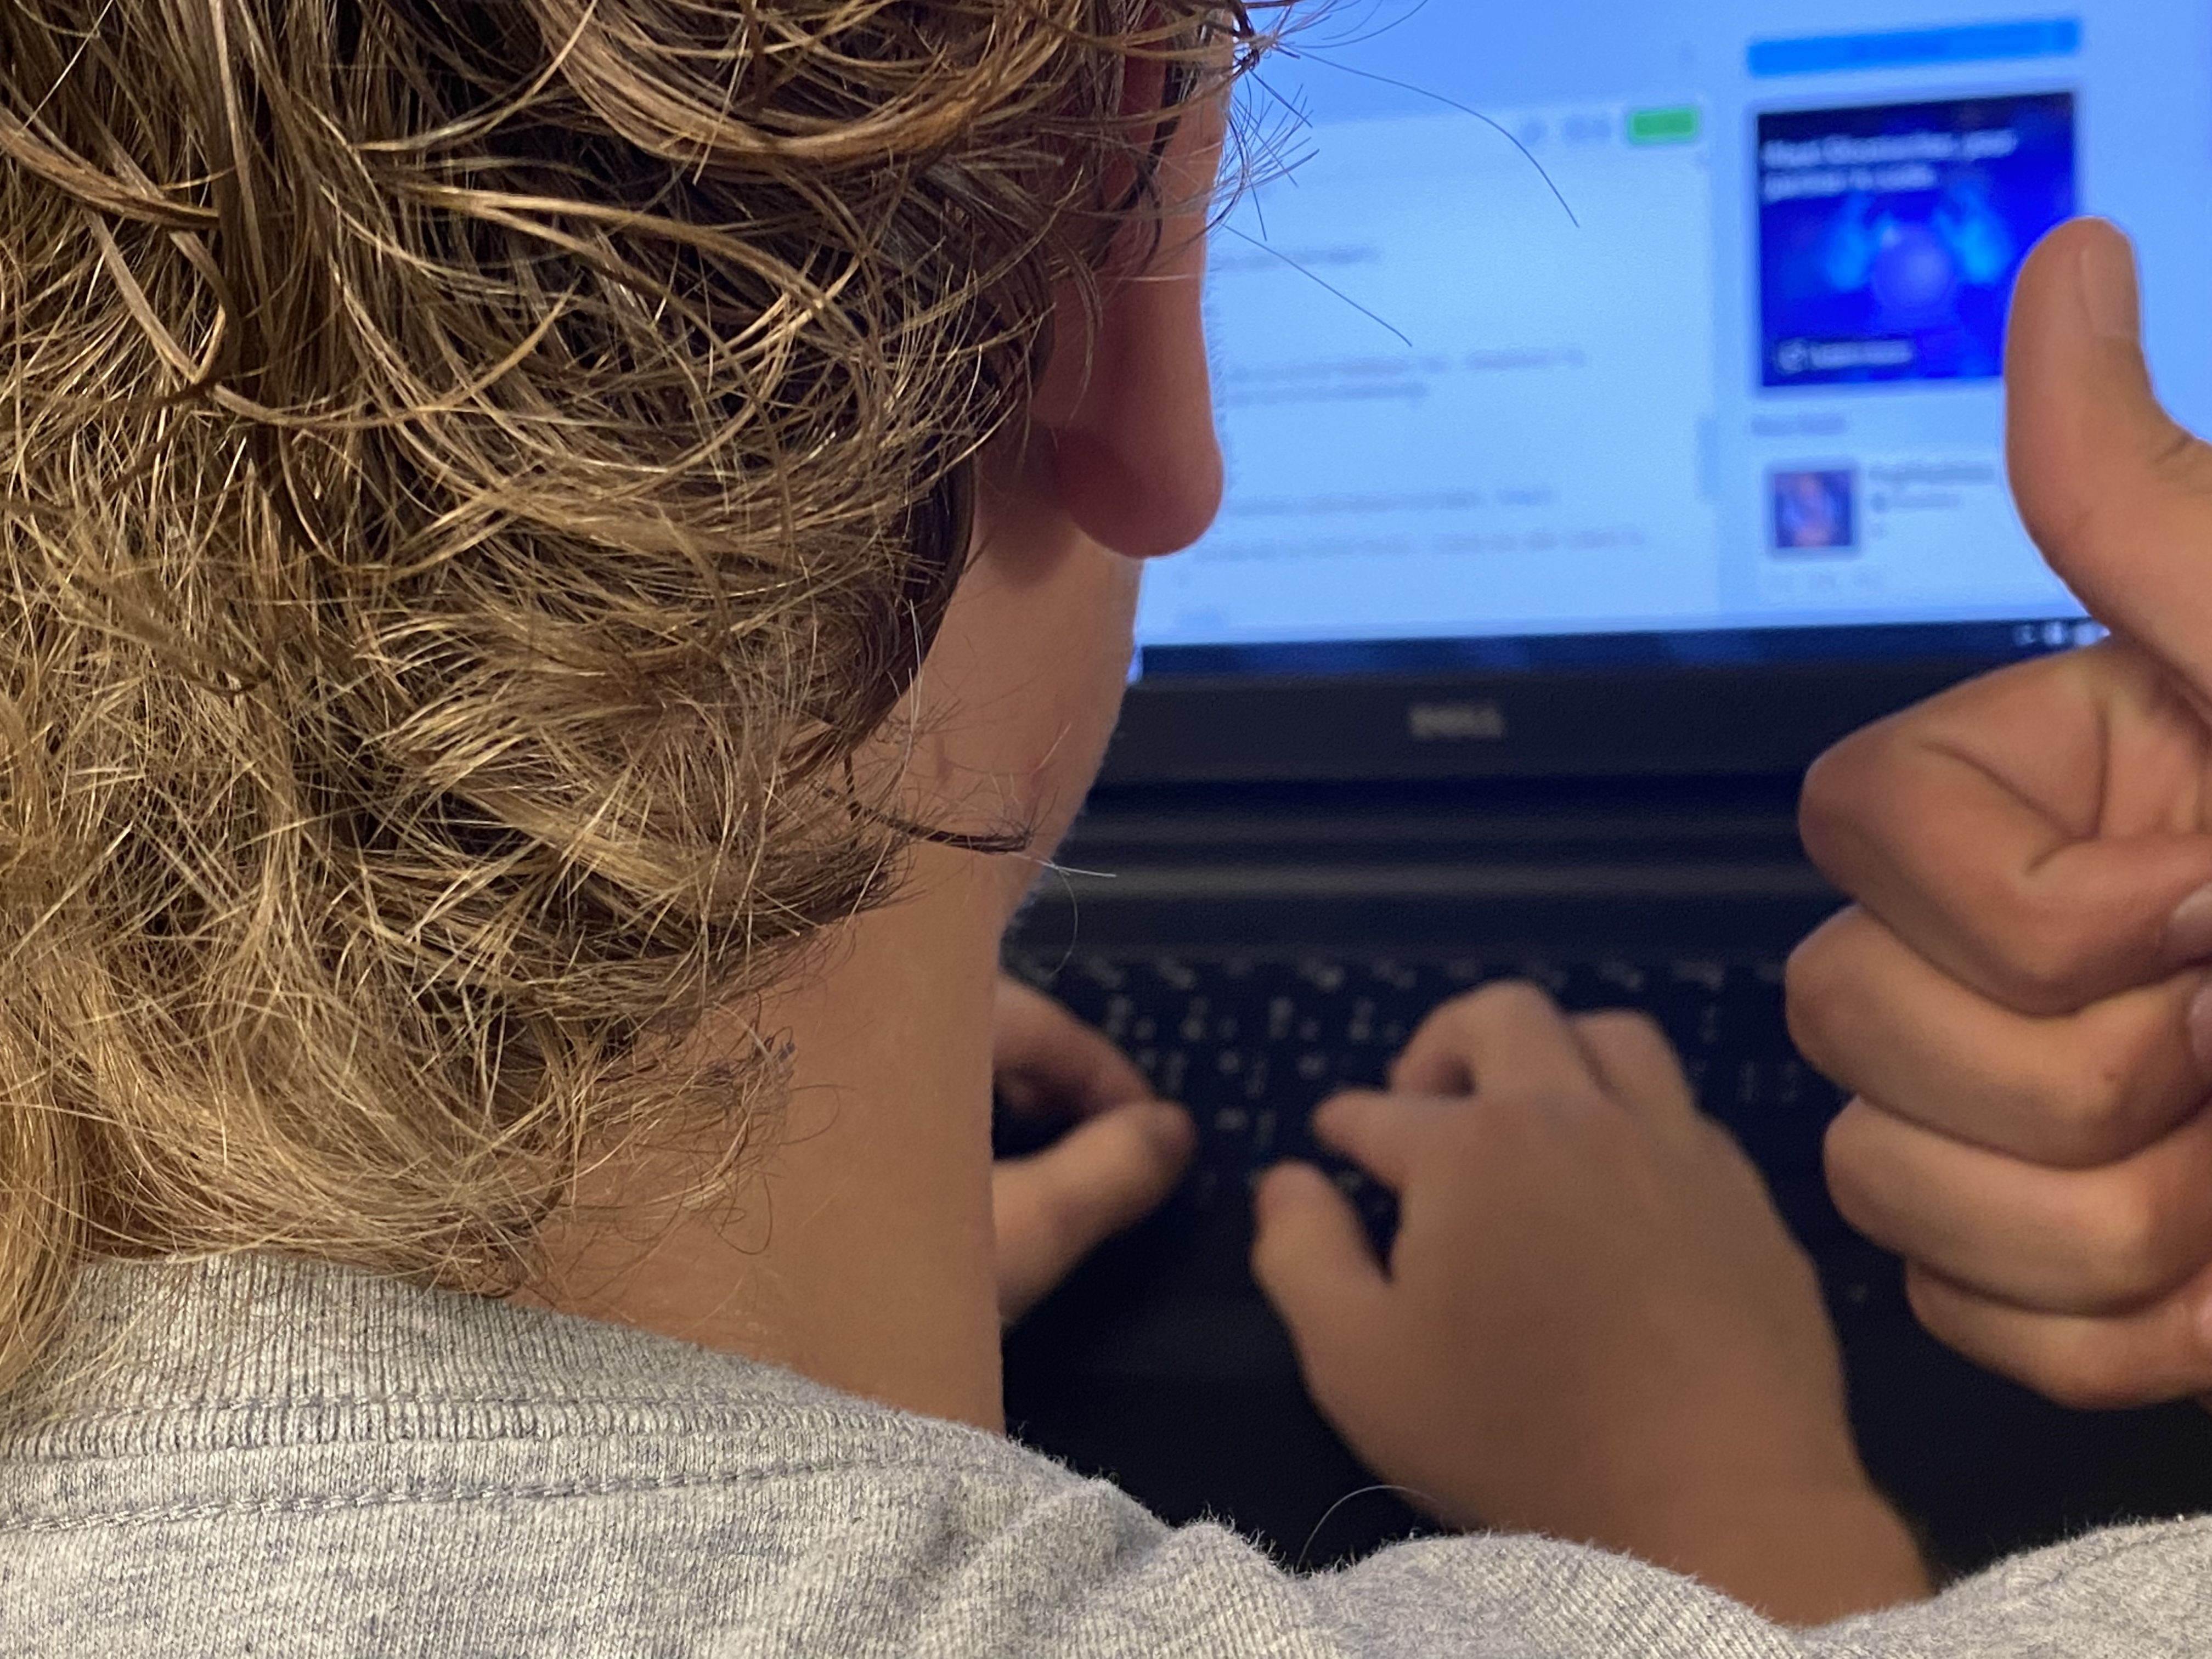

Meeting: information

* The in-person meetings were centrical to both the planning and implementing of our solution
* The in-person meetings also helped us develop our group identity
* While we had numerous in-person meetings, we constantly communicated virtually through GroupMe

Time Sheet

Hours

* Evan Hudson, Mileah Joy, Lee Laffitte packed and sorted sunglasses 2:30-5:00 on October 22
* Evan Hudson, Kobe Herrington built shelves 2:30-5:00 on October 29
* Delivered inventory program at 2:00 on November 6

Signature of Representative___________

Assessment/Solution of MedReach Inc. Needs

Assessment

MedReach Inc. is a non-profit Christian organization that takes multiple trips to Africa a year to provide both religious and medical support. Before each major trip of the year, they require help in packing and sorting medical supplies/basic goods. Therefore, Mighty Pythons decided to help them pack supplies. The volunteer work we did packing, and sorting sunglasses took two to three times longer because the paper inventory system we were reading was both inaccurate and hard to read due to the poor handwriting. Additionally, to these realizations, the MedReach Inc. rep. expressed the need for a better inventory system. Based on the inefficiency and the lack of an adequate inventory system, we realized the need for either a better paper inventory system or a digital one.

Solution

We came up with the solution of designing a java program that would not only keep track of the inventory in America but the inventory in Tanzania as well. To create the java program, we used the IDE eclipse because of its stability and limited space requirements. We then brainstormed several requirements the program must do. We then implemented the results of the brainstorm into the program. The code went through several iterations and versions in corroboration with MedReach Inc. to better suit their needs.

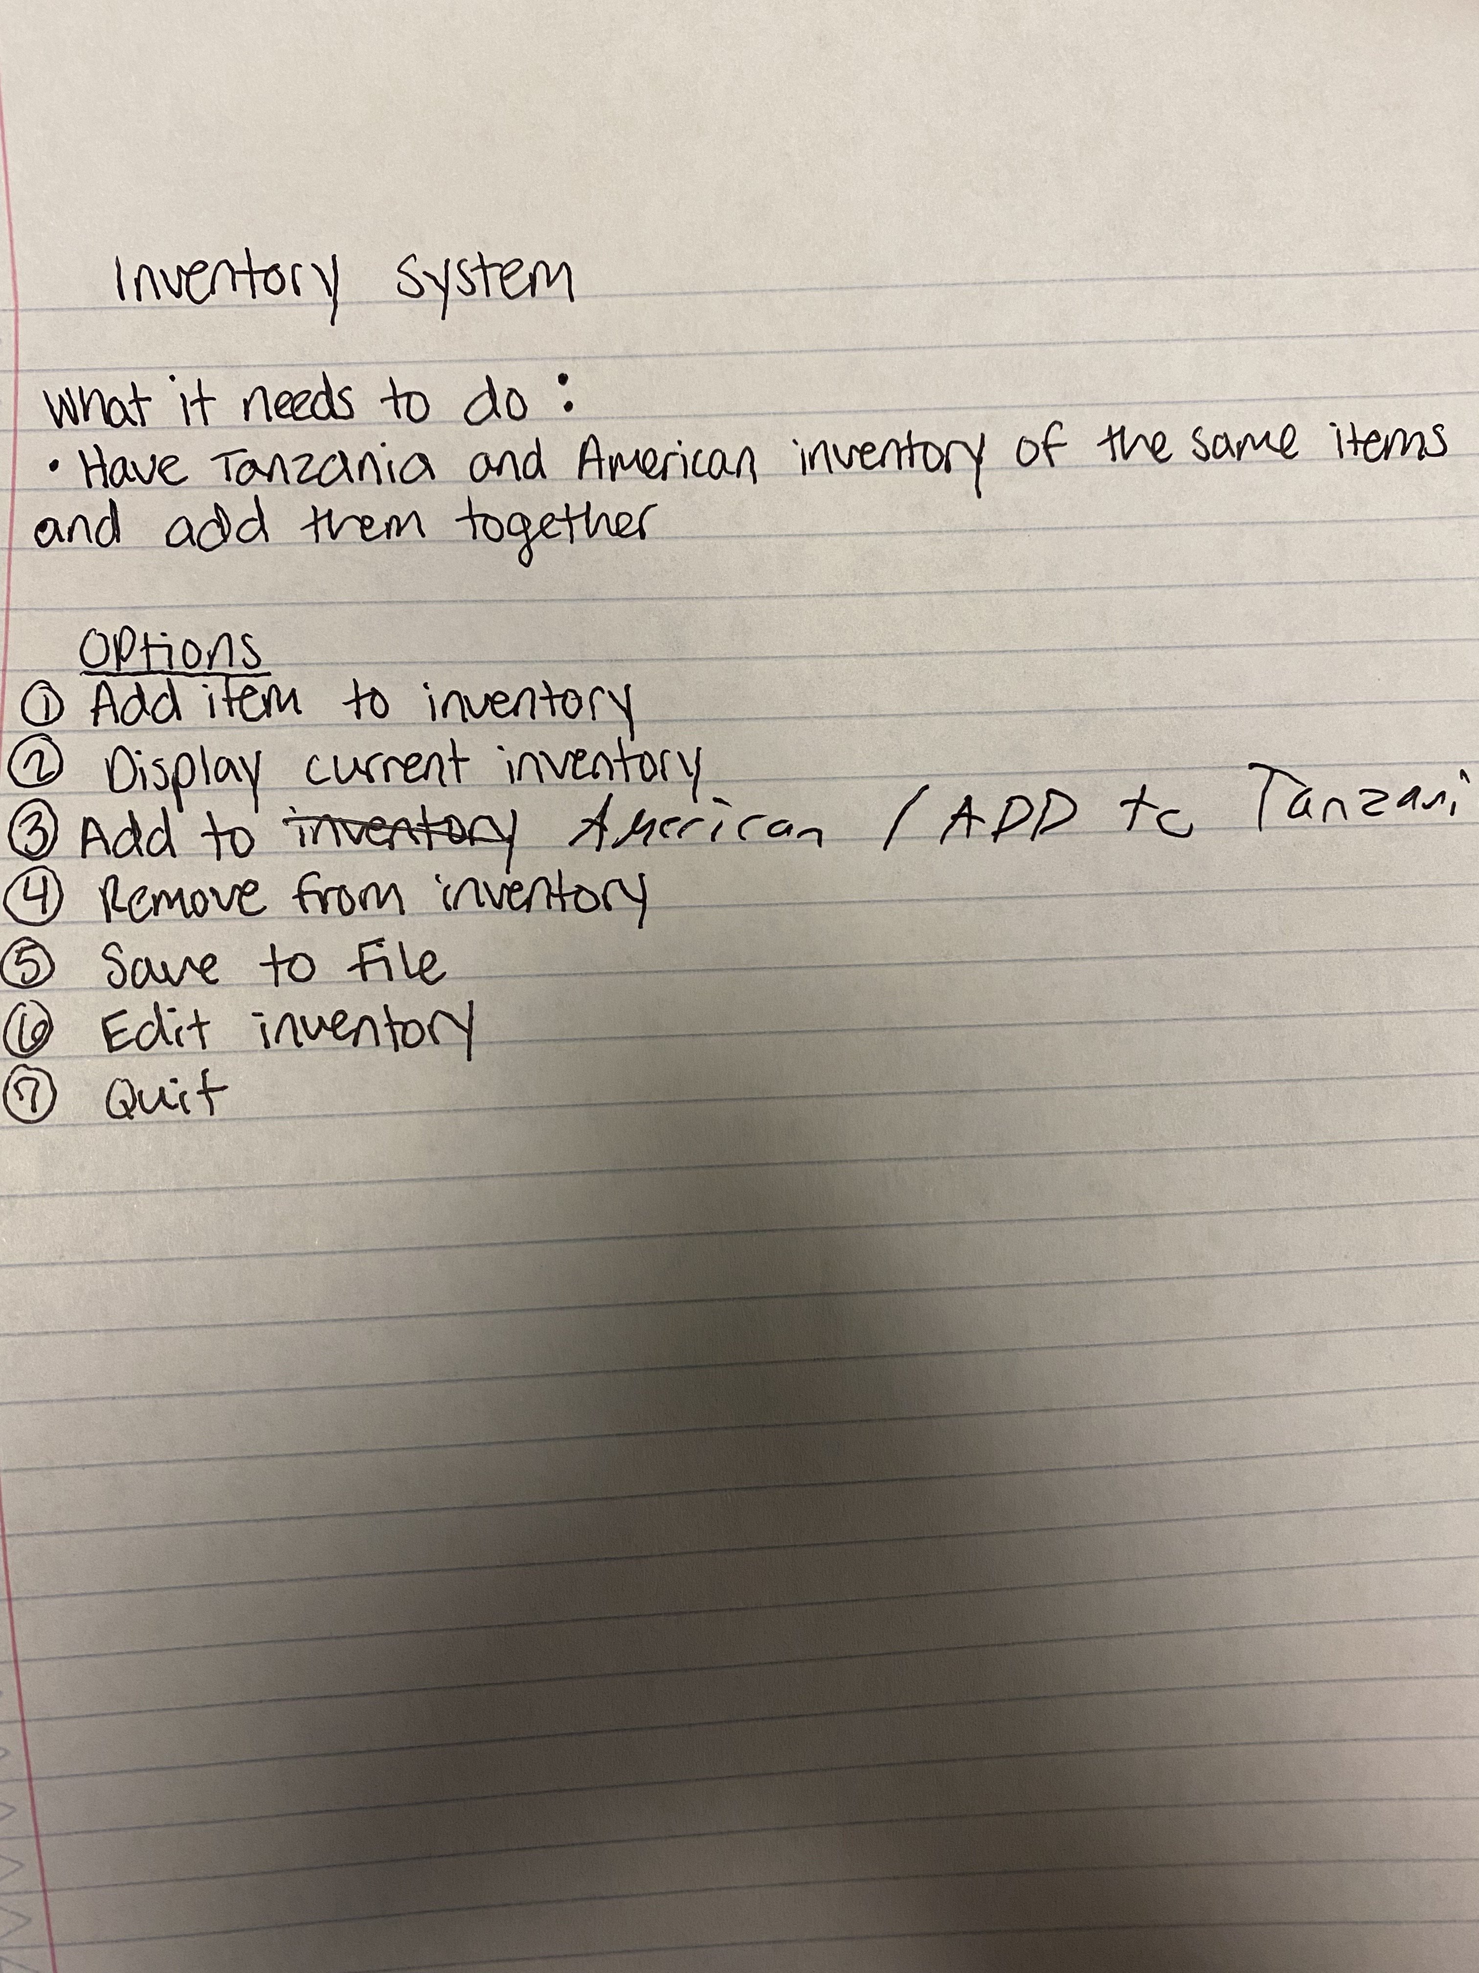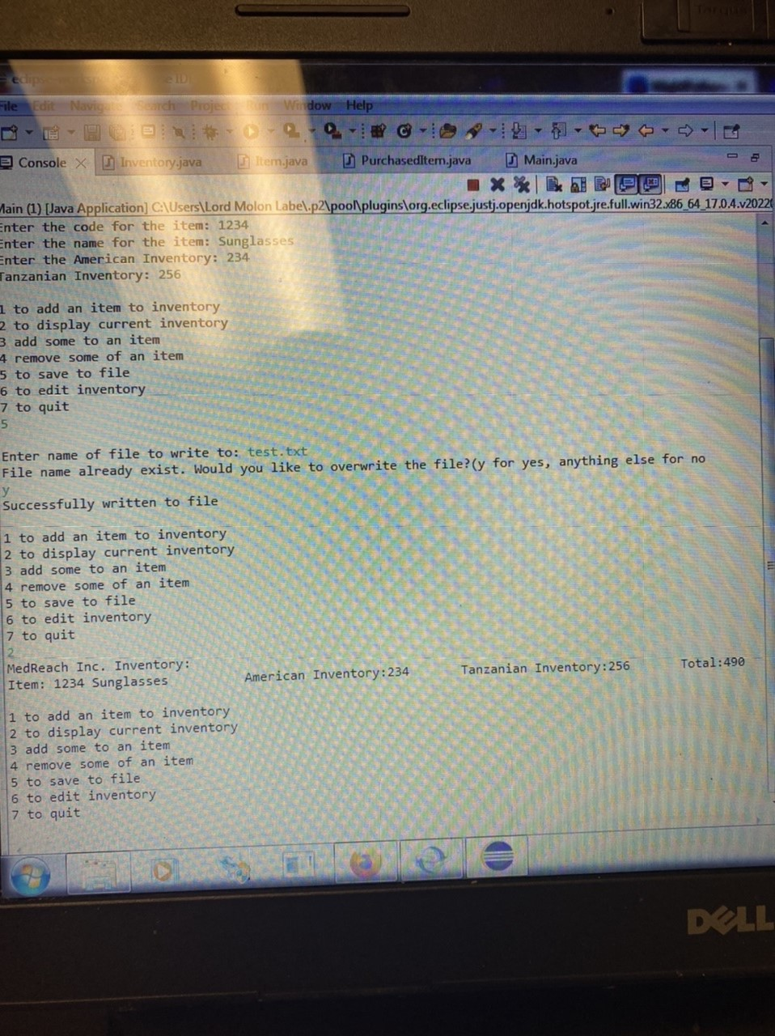

The Program

* Makes use of array lists to both store and add to the inventory
* It can both read and write the inventory in a .txt file
* It uses a user imputed code to allow for either adding or subtracting from an inventory
* The interface is simple enough/ intuitive enough for anyone to be able to use it
* It adds the compound inventories together automatically to display the total inventory of a product
* https://replit.com/@Deadpool123456/Inventory?v=1

Group Identity

General Systems Theory

General Systems Theory definitely manifested itself in our group. What is General Systems Theory well it is “elements, which are in exchange, and which are bounded”(*"General Systems Theory"by R. Gregory*, n.d.). There are many parts to a collection. Basically, it is saying that the whole is greater than its parts. In other words, a group is greater than the individual. It is stronger together than separate. This idea developed in several ways in our small group. The first way was in our group we decided to create a structure. The group structure was needed because in our group we were all interdependent with one another. We depend on each other to give feedback and or encouragement for one another. Also, in our group we wanted to create independence for each member to make their own decision on certain things that didn’t need the majority vote. Such as if a team member couldn’t make it on time to the volunteer event. We allowed them to reschedule and go on a day that was more convenient for that group member. Another instance of general systems theory, what occurred was that our whole situation was the sum of the ingredients. A very rudimentary example would be if you wanted to bake a cake and you had all of the ingredients, just because you have the ingredients doesn’t mean you will have a cake you just have the ingredients. These different approaches to this theory are unique in ways that can stretch across a lot of pages. There are so many different applications of this in our everyday lives. we have in our group to choose a couple different was to process this theory, but you have to realize that this is only a theory it is not a fact. It is merely an idea that has been based on general principles that people have used to explain why some groups work and others don’t. More specifically though, Systems Theory describes the group in relation to inputs, throughputs, outputs, and environment. In a group setting, this relates in a couple of ways. In other words, it manifested itself in a couple ways. The first way was in reference to the inputs. The inputs element of Systems theory relates in that we carefully choose inputs which were best for implementation. The group members all functioned as inputs. The mode of inputs was split into several different types. The information was inputted physically and digitally. It was inputted verbally and through text. Thus, the group was more suitable to accept input which was made possible by the creative environment that was produced by the systems we put in place to ensure adequate throughputs. The environment being suitable for creativity as a result of our brainstorm sessions lead to there being adequate throughputs. Because everyone was able to adequately listen, we were also able to adequately give feedback. By having a problem-oriented environment, we truly did our best work. We were able to produce an output as a result of the feedback from one another. For example, when designing the code, we were able to bounce ideas off one another to create the best most versatile code suited for the non-profit's need. Also to go with this, the relationships we developed by packing sunglasses and building shelves made it possible to feel a sense of loyalty to one another and more generally the group as a whole. Our ability to produce output was a result of the throughputs which was the result of the input which was a result of the positive environment that we created. General Systems Theory definitely manifested itself in our group which is evident in the synergy that occurred.

Ten Key Concepts

Concept 1: Seating Arrangements

The concept of seating arrangements was present in the group. We sat in a round table style so that everyone was close together and could communicate effectively. By choosing this style of seating, everyone was able to air their ideas. Plus, it meant that relational bonds were easier to form because it was a lot less strict. Everyone felt more at ease. Because the seating arrangements created a comfortability, it allowed creativity to flourish. In part of this, the brainstorm sessions were always exceptional because the environment was conducive to creativity. Another aspect of seating arrangement that was present was the seating of the leader. The leader sat in the middle of the front. By doing this, he was able to communicate with everyone on either side of him, while also being able to take a back row when brainstorming was occurring. With this in consideration, he was still able to be perceived as the leader when he needed to by being in the so-called “power seat” in front of everyone. At times though, we did use a more rectangular seating arrangement because it was more effective for our highly task-oriented meetings. By sitting in a more rectangular style, the leader’s power seat was more apparent which allowed him to take the lead in the conversations to assign tasks. For example, during our brainstorming meeting for the computer program, we sat in a circular seating arrangement, this allowed our creative juices to flow with everyone being able to air their ideas. During our assigning of volunteer dates, we sat in a rectangular style because it was highly task oriented and required more that the leader just tell people when and where. The communication concept of seating arrangement definitely was apparent in our time as a group. We purposefully and accidentally sat in places that were effective for efficient small group communication. The seating arrangement was just one part why we had an effective small group that accomplished our defined task.

Concept 2: Electronic Brainstorm

The concept of electronic brainstorming developed in our group. While we had a lot of in person meetings, the majority of our meetings took place digitally through GroupMe. By being able to bounce ideas back and forth through GroupMe at any time, everyone was able to have their opinions voiced. Further, if someone didn’t want to voice their opinion publicly, they could use GroupMe to message either the leader or another individual. With the rise of new communication technology, we implemented the new communication technology to the fullest. The electronic brainstorming sessions formed out of necessity with two members from our group not having a car. Thus, virtual brainstorming sessions were required so that everyone would still have an outlet to voice their opinions. In part of the electronic brainstorming sessions, we also held virtual meetings through facetime. This allowed us to brainstorm task-oriented roles as well as keep tabs on deadlines. It streamlined both the planning and implementing of our solution. The electronic brainstorming concept developed in the group because it was needed. Further, it allowed the group's creativity to flourish. For example, when discussing volunteer times, by seeing when everyone was available, it was easy to schedule times that the majority of the group was able to attend. The concept of electronic brainstorming definitely developed in our small group.

Concept 3: Cohesiveness

The concept of cohesiveness was expressed thoroughly in our group Mighty Pythons. Cohesiveness is when a combination of forces that glues people together in a group. Cohesiveness is “strength and extent of [interpersonal connection](https://corporatefinanceinstitute.com/resources/knowledge/terms/interpersonal-skills-2/) existing among the members of a group”(Team Cohesion, n.d.). The group's ability to relate to one another and express benefits like affection, power, prestige, and affiliation is what makes a cohesive group stick together. When we hold our group meet ups and have our conversations within GroupMe lots of cohesiveness is shown. Everyone is given their task by our leader and information and brainstorms flow without trouble. By having these silk smooth meetups and conversations, we as a whole group are able to achieve a lot within a short time span simply because we know what is required from each and every one of us. Having a good relationship with every member of the group is a fine example of how the Mighty Pythons were able to be so cohesive as no one had issues with one another. Conflict is good, but no conflict at all is definitely not a pro as much as it is a con, though in our group's situation, no conflict between one another made big decisions easy, conversing easy, and getting work done a lot easier. Another benefit that came from our group's cohesiveness is trust, as stated earlier we know what we have to work on and haven't failed to do our part of the assignment on time or to not come to a meeting without stating otherwise. This insane amount of trust between one another shows that we are all responsible individuals and capable of working together effectively. One last benefit that comes from our group's cohesiveness is the individual benefits that have come from the Mighty Python group to function so well. Everyone is satisfied one way or another, no conflict, or tension between members is shown, allowing us to be an effective group.

Concept 4: Virtual Cohesiveness

Cohesiveness is a group's ability to stick together when many contributing and complimenting factors manifest within a group. But a more specific element/concept that developed throughout our group was not cohesiveness in person but rather virtual cohesiveness. Cohesiveness in Virtual Teams is the same as cohesiveness, but less face to face and still able to glue a group together with benefits. Not being able to see one another face to face can make trust a bit wobbly as you do not know how that person truly is until more time has passed and you learn more about said person, or group. Another reason why Virtual Cohesiveness is much more difficult with the inability to be face to face and to provide process feedback and interpersonal relationships. It is even recommended by researchers that you do not build a group virtually, but face to face, then virtually since feedback will be more genuine since you are talking to a human being and not a technological slab that works off algorithmic code and science. In contrast to this, one article notes that some “videoconferencing is, in some ways, better than face to face meetings” (*Virtual Work Meetings During the COVID-19 Pandemic: The Good, Bad, and Ugly*, n.d.). For us though, while we maintained virtual cohesiveness through our expertise in using technology, it turned out that in-person meetings were a lot more effective. Within the Mighty Pythons, we have met many times face to face in class to discuss our plans for our project. Since our group is cohesive as it is, it was easy to describe what was needed within the time spans that we had. We are also able to critique and brainstorm easier face to face physically than virtually since insight is much more genuine. By having this much more genuine perk with face-to-face meetings over virtual ones our group is able to effectively work, and despite virtual cohesiveness being less stable than face to face cohesiveness, the Mighty Pythons are able to work either way and produce a satisfying result in the end.

Concept 5: Interpersonal Needs

The concept of interpersonal needs was expressed all throughout our group experience. According to William Schutz, every individual has three important interpersonal needs. These needs include inclusion, control, and openness. Our group definitely experienced all of these needs. In a small group setting, each individual and the group as a whole may experience each of these needs or recognize them. In our group, we would experience them many different times, some more than others. For example, during meetings, we would allow each other to express one's ideas and opinions on other’s ideas. Everyone felt like they had an equal say. This made every member feel included and heard even though there were members who took on a more leading role, therefore spoke more than others. We also tried to make sure to hold meetings and service projects when the most people were available to participate. We also made sure to hold multiple meetings and service projects in case a group member had to miss one. The second interpersonal need expressed in our group, control, was met by having a leader who would communicate with each group member and lead discussions. His task-oriented leadership allowed us to get our rather complex task completed. Our group also made sure to let each member have some sense of control over participating in individual aspects of the project. The last interpersonal need, openness, was achieved by our group due to the fact that we connected on many different subjects such as computer science and the goals we wished to meet for this project. It is even evident in our group decision to chose building a program for the non-profit. Each group member made sure to be open in expressing their ideas as well as their own opinions on each subject we discussed. The concept of interpersonal needs was definitely present in our group.

Concept 6: Listening Styles

A listening style is a preferred way of making sense of spoken messages. Active listening skills are essential for being an effective and contributing group member. There are four different types of listening styles that can be expressed in a group. They include relational, analytical, critical, and task-oriented. Different listening styles were present in our group many times throughout meetings and through communicating both online and in person. For example, when we were getting to know each group member at the beginning, we used relational listening in order to become more comfortable around each other. On the other hand, we may have used task-oriented listening while discussing the goals and agenda of our group project in order to focus on the task at hand. While in meetings group members expressed their ideas and suggestions, therefore the other members were using critical thinking in order to evaluate the information and provide their own insights and opinions or spot any inconsistencies or potential problems with the group member’s plan. Analytical thinking was used by all of the members in order to think through our facts and reach conclusions about the issues or faults in our plans. All of these listening skills were helpful in our group climate, creating a more comfortable environment or the serious atmosphere needed in order to get our goals and tasks completed in the end. In the process of listening and communicating during group meetings, our group also attempted to avoid listening obstacles such as prejudging the communicator and rehearsing a response in order to be the most effective and efficient we could be. By actively listening and participating during discussion and brainstorming sessions, the environment was extremely conducive to both creativity and accomplishing our task. Also, it taught us how to listen more carefully because someone who is a little softer spoken might have a good idea. For instance, Kobe talks a little quieter, but in a lot of the cases, he had really good ideas. The concept of listening styles definitely manifested in our group.

Concept 7: Small-group Ecology

Small-group ecology is the predictable method in which individuals position themselves physically in a small group is known as small-group ecology. There is a tendency for everyone in groups to sit down after the initial meeting, just like in a classroom. You choose your seats and don't usually move them until absolutely necessary. We are always inclined to stand or sit in a circle in our group. Each group member in that circle alternated between standing or sitting next to another group member, and so on. Our group's dynamic was effective and made it possible for us to work effectively. Throughout the semester, we continuously sat in this position, and it was effective for us. Every organization has members who interact and cooperate more effectively than others. Though, we were able to work together to complete or task. Everyone had their voice heard. This concept was very apparent in reference to our small group.

Concept 8: Structure

Structure is a technique for maintaining the objective of a group conversation. This entails utilizing an agenda, regulations, guidelines, and problem-solving techniques. Our group used structure in a variety of ways. We followed a schedule for our meetings, as well as for the event itself and the way we prepared it. Having a list of chores to do before the meeting or a list of duties to complete after the meeting is one example of the structure we employed in our meetings. All the things we needed to finish during that time together would be communicated beforehand or at the start of the meeting, and we would each perform our own tasks. Considering some of us had obligations prior to our event we had to employ problem-solving techniques and come up with a solution as a group if somebody was having trouble finishing their task. We could all keep on track and no one would have to battle alone. Although our group had structure, there were no internal regulations. We only asked that each team member do their part so that we could finish our duties quickly and without too many issues.

Concept 9: Groupthink

Some might wonder what Groupthink is. Groupthink is where members of a group decide on something that they must comply with in order not to cause conflict amongst the group. They will take the best interest of themselves and others in the group. When Groupthink happens, the members of the group are not analyzing, testing, and evaluating ideas. When you do not stand up for yourself and your group and become complacent because you don’t want any conflict, that can lead to more tension than just nipping it in the bud and causing the tension you were trying to avoid. In our group, it was formed because we all wanted to "maintain group loyalty “(Groupthink - Ethics Unwrapped, n.d.). Unfortunately, we slightly developed this mindset. In our group, we could have fixed how groupthink issue by not doing everything that someone said. More often than not, we just agreed and did not disagree with a thing that I personally would not have agreed with. Everyone in the group just wanted to go along with what the others said. If we had a minority idea, we didn’t want to go against the group. We also could have fixed this issue by not gaining the groupthink mentality. We just wanted to fit in and do the easiest thing as opposed to standing up for our idea. Further, we just wanted to feel a sense of belonging to our group. We felt such loyalty for our group we didn’t want to go against it. Once a group starts thinking this way, it’s hard to pull this group back into shape when you need them to come up with their own ideas or just think logically without someone being there. Groupthink becomes a group run by one group leader or multiple group leaders, and this group is turned into whatever the Leaders or Leader of the group.

Concept 10: Group Climate

Group Climate is the emotional climate or feeling in a group. In our group, we determined our group climate by watching everyone try to work together and figure out how to make it all fall together like a puzzle. Group Climate refers to the tone of the group. It's how the group also carries themselves because as they start to teach each other, they grow into a group that works well with each other, but the quality of a group is solely based on the students in the group. There are two ways a group climate can form. It can form as “defensive climate” or “supportive climate” (Beebe & Beebe, 2008, p. 80). Therefore, we made sure to set the tone to be problem oriented instead of control. Effectively, we set a positive tone. Without the tone set by the students or group members, the group will not succeed because without a strong force behind your team and a strong focal point. It will decide whether your group is just a group, or your group bring a great group. A strong problem-oriented climate formed which is evident in our ease to solve problems. For instance, during brainstorming sessions, we were able to have new ideas flood in every second. If a group doesn't have a strong group climate, it will dismantle the group before everyone even gets started. Luckly, we naturally developed a strong group climate. We did this by all staying positive and on task. Plus, our leader kept us focused and task oriented. At times, we were all a bit too agreeable, but in the end, it worked out. Therefore, we felt a sense of accomplishment. A strong group climate definitely formed in our group which is evident in our speed at getting the volunteer work done. Even the MedReach rep. was impressed by our speed in packing sunglasses. We had a strong group climate.

Individual Insights

Team Member: Evan Hudson

Doing this group project has led to several revelations in reference to several things. It has revealed both my strengths and weaknesses as a group member. It revealed my strengths in organization. For example, I was able to organize specific meeting times that were clear and at times that were convenient. In part of this, it revealed my strength in communication skills in that through digital communication in GroupMe where I was able to communicate what times would work best for everyone. Also, I was able to assign tasks that people carried out on time because I made sure that everyone understood what they had to do and gave them set deadlines. Through this project, it revealed that I was good at making sure everyone knew what to do so that we didn’t waste time through sheer confusion. I was able to be more of a task-oriented leader that suited this style of task specific project. That being said my work on this project also revealed several weaknesses. First of all, I was weak in being sterner on things like deadlines for tasks being completed. This resulted in several instances of things not being done on time and other things taking longer than they should have. Also, it revealed my weakness in trying to be a devil’s advocate because everyone was extremely agreeable on everything. It would have most likely been better to have some disagreement. I should have tried to insight some just to have some new fresh ideas result. Alas, I was unable to because I too can be agreeable at times. Since everyone was in agreement on everything, we didn’t have any fresh or new ideas pop up. This being said, I was still pleased with what we were able to accomplish to help the organization because it was something they seemed to really need. Furthermore, it revealed an aspect of my group interaction I need to strengthen. It revealed that I need to work on how to make sure that the group develops personally. We were an extremely task-oriented group, so we did not truly get to know one another as well as we could have. For example, during meetings, we would purely talk about what needs to be done with no breaks from discussing the tasks. Part of this is my fault because I chose to be a task-oriented leader. Therefore, in the future, I will make sure to put more focus on building relationships than I did in this group. Therefore, I am setting skill goals for myself to make sure I am stricter on certain things, creating an environment conducive to building relationships, and playing devil’s advocate. I can accomplish these goals by keeping the fact that I am weak at them in consideration. By keeping them in consideration, I will naturally be more conscious and aware when I am not prompting them. In the future, I will know if I have grown in these aspects if my group develops personal bonds, and they get everything done on time and are not so agreeable on everything. In conclusion, I learned a lot about myself and my role in a group setting through this project. By reflecting on what I have learned, it will lead to a consciousness that didn't exist before and will result in my overall skills in a group setting improving drastically

Team Member: Kobe Herrington

Insights on The Mighty Python are very few. We are a communicative group when we need to be. If we have a question about a task or assignment, we get together rather quickly and provide a precise answer. Though we have not met up much we have not needed to as we understand everything that we must do within the time span we are given to complete our projects' upcoming due date. Currently we are doing well on maintaining and achieving our goals for the non-profit organization project. My role is to be a support–at least I see myself as such. mostly at least. I do my end of the work as everyone else does and we go our separate ways until the next meeting where we meet and progress together more. Recently, Evan and I were working on our community service, helping Mr. Steve build shelves in his storage room for his crates and other items so that it took up less room and was easier to move through the compact room. Evan and I were cutting the boards up, helping Mr. Steve aligned the shelves to progress towards the final product of nailing the boards into place. When we were working on the top shelf neither Mr. Steve nor Evan could reach it, but I was tall enough and light enough to balance off some of the boxes to nail the boards together so the shelf could hold items. Though our group is straightforward and to the point on our tasks we interact so little, but only because we all know what we are doing and where our areas of expertise fit the most in The Mighty Python. We meet up mostly during class to get all of our information on where we currently are and then we depart to work on our tasks. Most I could improve as far as interaction would be to speak more, but it wouldn’t be much related to our project as we already know what is needed out of each and one of us. A good example would be last Tuesday when we all agreed to meet–if we could make it without issue–for our next community service assignment. Specific goals I could improve on group interaction effectiveness would be socializing. There is not much in general but being an ice breaker is not too hard if you are confident enough in yourself to start a conversation with others. Steps I could take to achieve this goal would be to be more confident in myself and maybe a bit less antisocial at times when our group does have conversations that do not relate to our project. I’ve always been antisocial since middle school as I began to understand that four quarters are better than one hundred pennies, but those four quarters would have their own change as well, so it was hard keeping up with people I made friends with. I will know that this goal is accomplished by just communicating with the group more when it’s not necessary, but more or less just wanted out of personal satisfaction.

Team Member: Todd Askren

Working together with other people for an assignment can be a challenging task in some cases but luckily, I worked well with my group members. The decisions we made were anonymous although we paced ourselves individually when it came to completing our separate parts of the essay. As a group I believe that we connected well on an interpersonal level as all four of us were able to make alterations to any problem together. Furthermore, we did not give each other a chance to get angry at one another as we knew that this would only cause conflict that would disrupt our flow as a group. There was an equal divide in the amount of work that we all did; our contributions were fair and no one was lacking behind. In addition, my group members were great at keeping each other informed if one of us were not able to attend a group meeting; emails were sent out informing us what we missed and ideas that were formulated. Everyone in my group worked according to deadlines and in synchronization with each other; we did not have to nag anyone to complete work or wait on a member to complete their task. As a group, we were able to brainstorm and formulate themes together so everyone knew what the other member was writing about in order to avoid last minute confusion.

The themes present in the report are an avid representation of the support structure within our group. For example, I was constantly running into scheduling issues when it came to volunteering, but I was able to pick up the slack when creating the code for our organization system. Coming up with the idea to move it to RepLit, and writing most of the code. Having the right people in the correct roles is an important factor in measuring the success of a team, where you are united with the other members to complete the main goals. Every group is made up of definite strengths and weaknesses. Our team's 3-5 major strengths necessary to work accordingly consist of Informer, Summarizer, Orienter, Piggy-Backer, and Encourager. One of our strengths as a team is that we get input from everyone involved. Every member of our team is a leader in some way. Part of being a good leader is knowing how important it is to receive the best ideas from each member of their team. We attend group meetings where we discuss any challenges, issues, and problems. At these meetings, we often exchange ideas or brainstorm new ones with each other and come up with the best and most creative team solutions as potential answers to those perceived problems. As a team, our second team leadership role is that of a Summarizer.

We're all good recorders/communicators seeing as how everyone takes notes on team progress, team decisions, and any assignments that need to be completed in the future. We created an agenda for the team and at the end of the group meeting the recorder of our group would then distribute copies of the responsibilities we equally share across the team to each team member. Our third team leadership role is that of an Orienter. We're all good timekeepers. For example, we have someone who facilitates the team meeting, someone who manages the agenda, and someone who keeps track of time. The Orienter writes down ideas and manages the conversation to ensure that the group doesn’t get off topic creating a constant flow of ideas coming from every individual. I was not perfect throughout this entire project, in fact I was far from it, but I put in more effort to make things work than anyone else in the group. Wherever I lacked and fell behind in attendance and participation, I picked up more slack in doing work for the group, a prime example of that is the code. I was unable to attend some of the volunteering events, so I came up with an idea where I could still do my part and made it happen. At the end of the day, I wasn’t perfect and everything didn’t go exactly the way that I had hoped that it would, but I still did everything in my power to make a difference and pull my weight.

In conclusion, I feel as if we built trust in our team. Seeing as how we’re leaders in our own way, we each created a culture of trust among ourselves. Once we got to know each other personally and shared some personal information about ourselves, our families, hobbies, and other interests, that’s when we started to develop a bond and all the trust built up between us. And this paper assessed our group’s 3-5 major strengths and weaknesses and what successful strategies we hope to add to our team to build a more effective team in the future. Thank you for reading.

Team Member: Mileah Joy

Working with a small group and helping an organization in its pursuit of making the lives of others more comfortable has helped me learn more about myself and how to communicate with others. I have learned a lot about the “group experience” as a whole throughout this class and through the entire group project that we have produced. It has helped me realize some of my strengths and weaknesses, as well as many other aspects of my personality, social behavior, and ability to work with others. I showed many of my strengths by giving feedback, making suggestions, and compromising with the other group members. Although I had never done this before, I took on the role of taking minutes and documenting our group's meetings as well. On the other hand, my weaknesses showed when prompted with hard decisions to make, and when I needed to share my own ideas and suggestions in front of the whole group. These weaknesses could definitely be improved and worked on, but some things will never go away fully, such as my social anxiety around new people and difficulty in making quick decisions. In our group meetings, I may have had problems communicating effectively at first, but they definitely improved once the initial awkwardness and tension were slowly alleviated. Three skills that I would like to improve on in the future are my group communication skills, my public speaking skills, and my decisive thinking skills. I would love to be able to communicate more confidently with future group members and colleagues that I may be working with in my career in the future. I have always been a “shy” person throughout my lifetime, and public speaking has always proved to be my worst enemy. Therefore, being able to work on my skills in public speaking would benefit me greatly in things such as presentations and job interviews. As for decisiveness, I think that improving this skill will greatly aid me in my future career and may even qualify me for more leadership roles in the workplace. Accomplishing these goals, I believe, will take some time because they all require repeated experience. These goals can’t be achieved by reading books or watching youtube tutorials overnight. I will need to involve myself in situations where I will need to communicate with others, do projects that require presentations, and work with others on making decisions. All of these skills require other people in order to improve. I know that I have accomplished these goals once I feel confident and comfortable around others and in front of others while speaking or sharing ideas. Participating in this class and this group project has allowed me to make my first step toward achieving these goals. Although I am not even close to full confidence and comfort, I believe that this project let me realize where I want to see myself in the future. Communicating and working with others may be difficult at first, but I believe that I can only improve through experience.

Team Member: Lee Laffitte

In this time of me being part of this group, it has taught me a lot about not only myself but how I work with others. This group has allowed me to sit back and figure out my role in the group. During the time we have been in this class, I have learned that I have more weaknesses than strengths. My main weakness is time management because I work so much, and I often only get home at 8-8:30, and by that time, I am tired and do not want to do anything else. Another area for improvement is that I need help understanding half the things my group members are talking about. To fix this issue, I have learned that no one is afraid to help you if you ask questions. While working with small groups, whatever a person puts in is what you will get out; this means anytime you do not give 100 percent, you will not get 100 percent from not only yourself but your team members as well. To improve my interaction with my groupmates, I should have been more straightforward instead of sitting to the side and not giving much input on specific topics. Such as us deciding what to do for our service project or just accepting what task I was given. Putting more input would not only make me more involved, but often, more than not, I wouldn’t be confused like I am most of the time because I haven’t been involved with interaction. In my other classes, I have noticed that I don’t like interacting with my peers. This will later hurt me because I will end up missing opportunities that could benefit me in the long run. I have determined that I have a few goals to reach by this time next year. My first goal is to become more social; when you are more social, you become more approachable. The second is to stop working so much. Even though I love my job and the children, I need to learn to let go and start taking personal time for school and myself. You hear many people speak about personal time, but you don’t really understand until you find out when you need the personal time. Lastly, I just need to focus. Focus on one area or one thing at a time; if you keep jumping from one thing to another, you will never be able to complete the task at hand. There are a few different ways to accomplish the goals that I have created, to name a couple like Nike, just do it. In order to get anything accomplished, you have to have the courage to do it and to do it the right way. The next way to conquer my goals is to do more evaluate how my decisions can change the outcome of how I complete the task. I have learned a lot from this group work. I have learned how I fit into group work. Furthermore, it has made me like group work that much more. I like being able to brainstorm and bounce ideas off one another. Group work isn't so bad.

References

Beebe, S. A., & Beebe, S. (2008). *Communication in Small Groups: Principles and Practices* (9th ed.). Allyn & Bacon.

*"General Systems Theory"by R. Gregory*. (n.d.). Welcome to the World-Systems Archive. <https://wsarch.ucr.edu/archive/papers/gregory/gensysTh.html>

*Groupthink - Ethics Unwrapped*. (n.d.). Ethics Unwrapped. <https://ethicsunwrapped.utexas.edu/glossary/groupthink>

*Team Cohesion*. (n.d.). Corporate Finance Institute. <https://corporatefinanceinstitute.com/resources/management/team-cohesion/>

*Virtual Work Meetings During the COVID-19 Pandemic: The Good, Bad, and Ugly*. (n.d.). PubMed Central (PMC). <https://www.ncbi.nlm.nih.gov/pmc/articles/PMC8165498/>